**http://leka.io/**

[**http://www.dailymail.co.uk/sciencetech/article-3383778/Meet-Leka-social-robot-designed-help-children-autism-learn-new-skills-using-lights-vibrations-sounds.html**](http://www.dailymail.co.uk/sciencetech/article-3383778/Meet-Leka-social-robot-designed-help-children-autism-learn-new-skills-using-lights-vibrations-sounds.html)

**Meet Leka, the vibrating 'social robot' designed to help children with autism learn new skills**

* **Leka was unveiled at consumer technology show CES 2016 in Las Vegas**
* **It provides sensory stimulation through lights, vibration and sound**
* **The robot could help make learning and social interaction easier for children with autism and Down's syndrome, claim its makers**
* **The company is currently raising funds on French website ' sowefund '**

By [Ryan O'Hare for MailOnline](http://www.dailymail.co.uk/home/search.html?s=&authornamef=Ryan+O%27Hare+for+MailOnline)

Published: 13:35 GMT, 4 January 2016 | Updated: 18:44 GMT, 5 February 2016

The role that technology plays in the treatment of children with autism has been known for some time, but now a company has developed a robot designed specifically for people with the condition.

Called [**Leka**](http://www.leka.io/), the motion-sensitive bot lets children play learning games by providing sensory stimulation through movement, lights, vibration and sound.

Its makers have likened it to a 'guide dog' for children with the condition, helping them to navigate the challenges of learning and social interaction.

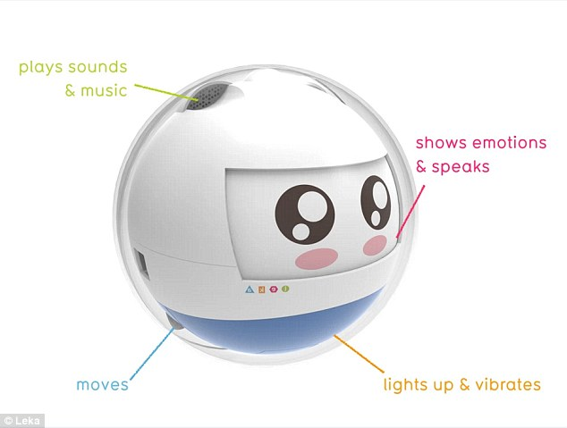Leka has been unveiled at global consumer electronics and technology tradeshow CES 2016, in Las Vegas. According to its makers, the interactive robot (pictured) can help to stimulate children with developmental disorders such as autism spectrum disorder and Down's syndrome, or multiple disabilities

The little, round robot is on display at the global consumer electronics and technology tradeshow CES 2016, in Las Vegas.

According to Leka's makers, the interactive robot can help to stimulate children with developmental disorders such as autism spectrum disorder and Down's syndrome, or multiple disabilities.

***AUTISM AND ITS EFFECTS***

*Autism is a neurological disorder that affects how a person communicates, and relates to, other people. It can also affect how they make sense of the world around them.*

*People with autism typically have trouble communicating, looking people in the eye, and can get upset by loud noises or bright lights.*

*They may also have a sensitivity to touch, tastes, smells and colours.*

*In particular, many autistic people like order and predictability.*

*Autism is a spectrum condition, which means that while all people with autism share certain difficulties, their condition affects them in different ways.*

*Some people with autism, for example, are able to live relatively independent lives but others may have accompanying learning disabilities and need specialist support.*

It has been designed as a tool to help parents and caregivers teach their children using play through therapy in their own homes.

The model revolves around the concept of gamification, where typical elements of gaming, such as point scoring and competition, are applied to learning to make it more accessible.

A selection of single and multiplayer games will be available to users to help develop motor and intellectual skills.

Current game applications include hide and seek, a colour-based bingo and 'touch-blink-spin'.

Chief executive and founder of [**Leka**](https://www.facebook.com/WeAreLeka), Ladislas de Toldi, said that the robot 'could be the guide dog of autistic children.'

He explained: 'As a robot, Leka is both predictable and stable in its interactions, which is very important for the child's sense of safety and serenity.

'Leka caters to the specific needs of the kids and focuses on multi-sensory stimulation. Its colours, sounds, vibrations help improve sensory processing and reduces anxiety.'

Speaking to [**BBC News**](http://www.bbc.co.uk/news/technology-35204679) at CES, Mr de Toldi, said: 'Children with disabilities are still children. They want to play, they want to have fun.'

He added: 'If you use the robot as a learning support for learning activities, the children become more engaged in those activities.'

According to de Toldi, the next steps for Leka include plans for a screen so it can display emotions as well as sounds.

Leka founder , Ladislas de Toldito de Toldi (left) said the next steps include plans for a screen so Leka (right) can display emotions as well as sounds. A number of single and multiplayer games are available to help develop motor and intellectual skills, including hide and seek, a colour-based bingo and 'touch-blink-spin'

The company has designed a prototype and is currently raising funds on French crowdfunding website '[**sowefund**](http://leka-sowefund.strikingly.com/)' to mass produce it.

The team is also reportedly working with researchers in Paris and the UK.

Mr de Toldi added: 'We base our developments on research which has been done in the United States and in the United Kingdom as well.

'With the help of parents, with the help of caregivers, we are pretty sure that this robot is going to help the children who are using it.'

Such social robots like Leka are part of an emerging suite of technologies being used to help children with autism learn and improve their communication skills.

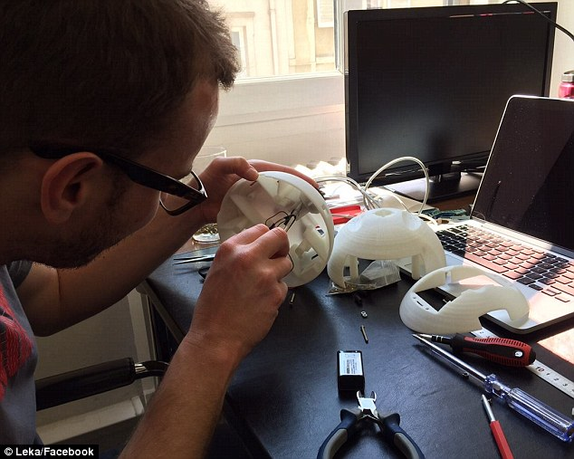

+3

The company has designed a prototype and is currently raising funds on French crowdfunding website 'sowefund' to mass produce it. The team is also reportedly working with researchers in Paris and the UK

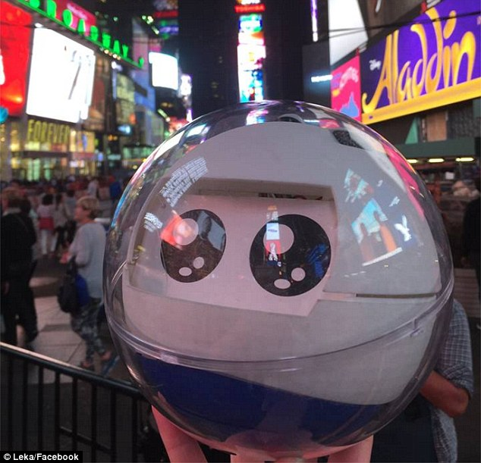

+3

The team is reported to be working with researchers in Paris and the UK. Chief executive and founder of Leka, Mr de Toldi, said that the developments are based on research done in the United States and in the United Kingdom and that the firm is confident the robot is going to help children using it

A number of apps are available which help affected children to feel safe and communicate more readily because as software is more predictable and ordered than human interactions.

Swedish company Toca Boca, for example, has created a number of apps aimed at children aged three to six.

Toca Band encourages children to make music and learn about rhythm and tempo, while Toca Hair Salon Me lets players give their family and friends virtual haircuts.

Although the games are not specifically designed for children with autism, they have proved popular among parents who have children with the condition.

'This is a very exciting time for autism, with lots of innovative work going on around virtual reality, communication apps and wearable technology to measure things like stress levels,' said Carol Povey, director of the National Autistic Society's Centre for Autism.

Commenting on Leka, Ms Povey told MailOnline: 'This prototype is one of a range of emerging technologies which have the potential to transform the lives of people on the autism spectrum.

'Many autistic people are drawn to technology, particularly the predictability it provides, which means it can be a very useful means of engaging children, and adults too. We use a range of devices and technologies in our own schools, including iPads, cause and effect toys, and software like Games Maker Studio and Minecraft.'

She added: 'This robot is still in development but holds a lot of promise. We're particularly interested by the team's plan to collect data on children's interaction with the robot and how this data could increase our understanding of autism.

'In the long term, we hope this data will inform better support for people on the autism spectrum.'

***HOW TECH IS BEING USED IN THE CLASSROOM WITH AUTISTIC CHILDREN***

*In a recent study, researchers from Canada studied 12 children in six classrooms across Ontario, all of whom have non-verbal autism spectrum disorder.*

*These classrooms were given Apple iPads for a six-month trial.*

*Following the experiment, nine of the students showed a statistical improvement ranging from mild to significant in their overall communication skills.*

*The devices were also found to boost motivation among 75 per cent of the children, while also increasing their attention span and ability to interact socially.*

*Topcliffe Primary School in Birmingham recently introduced touchscreen devices into classrooms and similarly noticed an improvement among the autistic students.*

*'We watched children with autism playing with the images on the screen in ways in which none of the typically developing children had done, said Topcliffe's spectrum disorders teacher Sarah Quickenden.*

*'The normal curriculum that we were offering just wasn't allowing them to demonstrate these skills to us. We never realised that the children had these skills because some of them are so locked in.'*

Read more: <http://www.dailymail.co.uk/sciencetech/article-3383778/Meet-Leka-social-robot-designed-help-children-autism-learn-new-skills-using-lights-vibrations-sounds.html#ixzz45YwsWj27>   
Follow us: [@MailOnline on Twitter](http://ec.tynt.com/b/rw?id=bBOTTqvd0r3Pooab7jrHcU&u=MailOnline) | [DailyMail on Facebook](http://ec.tynt.com/b/rf?id=bBOTTqvd0r3Pooab7jrHcU&u=DailyMail)